Ben
Weekly Relays User Guide
TOPICS LEGEND
 |  | WEEKLY RELAYS |  | August 31, 2017
YOUR DEPARTMENT NEWS |  |  | UTMB NEWS
IMO  IMO welcomes two new staff members, Jade Matejka and Amber Torres-Milburn. Many thanks to all the IMO staff for their hard work this week ensuring our classrooms were prepared for students and assisting faculty in the restructuring of their courses. It has been a difficult week for all and their commitment to our students and faculty is greatly appreciated.  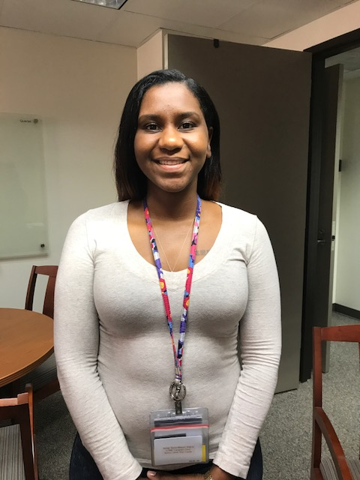  Amber Torres-Milburn  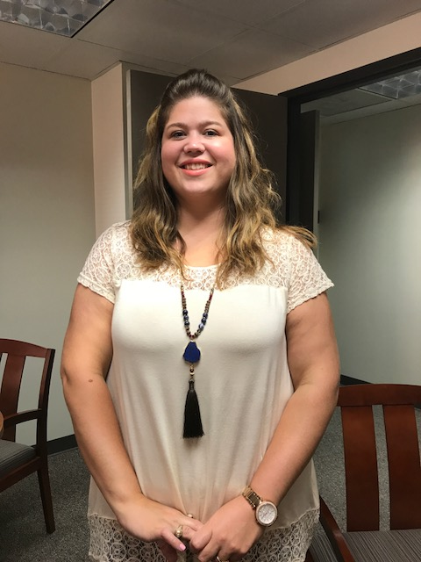  Jade Matejka  OSSA  Weathering the Storm Student Support Groups  Jamail Senate Room  September 5, 4:00 PM  September 6, 12:00 PM  September 7, 4:00 PM  September 8, 12:00 PM  For more information contact Student Health & Counseling at 409-747-9508. |  |  | Hurricane/Tropical Storm Harvey has tested UTMB—and UTMB aced the test. Thank you to everyone for your efforts to preserve our mission during this prolonged challenge. In the days ahead, your commitment and dedication will be increasingly important as more patients are able to reach us, as our students return and as our communities begin their recovery. If you haven’t had a chance to see it, please read the message from University of Texas System Chancellor Bill McRaven regarding the stellar work of UT health institutions’ work throughout this crisis. You can read it at https://ispace.utmb.edu/xythoswfs/webview/_xy-17097352_1. Chancellor McRaven plans to visit the UTMB Galveston Campus on Friday to hear from employees throughout the institution who worked tirelessly during this trying time to care for others. Harvey’s aftermath will give us an opportunity to demonstrate yet again how we work together to work wonders.  Normal operations to resume Friday, Sept. 1:  UTMB will remain on emergency status through Aug. 31 and will resume normal operations at 7 a.m., Friday, Sept. 1. See President Callender’s related message. Many UTMB faculty and staff live in areas directly affected by the flooding and UTMB continues to prioritize the safety of employees, students and patients. All supervisors should contact their team members by 3 p.m., Aug. 31, to determine their needs and manage their return to work. Any supervisor who is unable to reach an employee by then should contact their Human Resources consultant. While normal operations are set to resume Friday, please continue to monitor local weather and road conditions, and obey emergency management instructions for your area. Do not attempt to travel if it is unsafe for you to do so. Resources for checking road conditions include:  - Texas Department of Transportation  - Houston TranStar  Good news on our facilities:  Despite the widespread damage throughout Southeast Texas, UTMB facilities have fared very well. We did experience some minor leaks here and there, and there were intermittent telephone and Internet outages at the height of the storm; however, our campuses in Galveston, Angleton Danbury and League City stayed open during the storm and served patients throughout the event. With a few exceptions, our freestanding clinics are now back in operation and we are actively working to bring the others back into service. Our research and education facilities are fine. Some of our CMC units had to evacuate their patients when flooding reached the prison units, but our staff has done and is doing an admirable job in getting their patients and themselves to safety.
TOPICS  LEGEND | PATIENT CARE EDUCATION & RESEARCH INSTITUTIONAL SUPPORT CMC
AROUND UTMB (Use the legend above to quickly find items of interest to your team)
Park-and-Ride services:  Park-and-Ride services between Galveston and League City will resume the normal schedule Friday, Sept. 1. In addition, Park-and-Ride will be available Saturday, Sept. 2 through the Labor Day holiday (Monday, Sept. 4) to assist employees who work weekend/holiday shifts and are without transportation due to the storm.  Parking facilities update:  A reminder that all employees should now be parking in their regular spaces.  Disaster relief website established:  To support our faculty, staff and their families during the recovery phase, UTMB Human Resources has created a disaster relief resource web page at https://hr.utmb.edu/relations/disaster_relief/. Check the page regularly as it will be updated as new information is available.  Disaster Relief Resource Centers:  Human Resources is also setting up Disaster Relief Resource Centers for UTMB employees. The centers will be available Sept. 1, 2, and 5-8 from noon to 8 p.m. on the Galveston, Angleton Danbury and League City campuses. There will be in-person or direct phone access to the Employee Assistance Program during center hours. For more details, visit iUTMB.  Employee Assistance Program:  Harvey and its aftermath will stress our communities, our families, our friends and our co-workers. Please be on the lookout for signs of stress in yourself and those around you. Employees and their families are encouraged to contact the Employee Assistance Program, available 24 hours a day, 7 days a week at (844) 872-5986. This resource can help the UTMB family manage stress and access other services in the community. If you’re a UTMB supervisor, please help connect employees to EAP resources.  School’s back in session:  UTMB is set to resume classes on Tuesday, Sept. 5, following the Labor Day holiday. Information regarding online coursework is being sent to students directly from the respective school deans at this time. |  |  | Access2Care for employees:  As many of our employees will be coming back to the Galveston Campus on Friday, Sept. 1, we will begin offering same-day access for primary care services at the Family Medicine Clinic in the Primary Care Pavilion. Please contact the dedicated employee Access2Care line at (409) 772-2273 (772-CARE) to schedule an appointment. We continue to offer urgent care services at all of our urgent care locations except Texas City.  Giving blood:  We have had numerous inquiries from employees interested in donating blood. UTMB does not have a blood donation center, but if you’re interested in donating, contact the Gulf Coast Blood Center location in Pearland at (713) 436-7722 or the Pasadena Blood Center at (281) 487-1055.  Events postponed or rescheduled:  Due to the effects of Tropical Storm Harvey, several events have been postponed:  - Next week’s New Employee Orientation has been rescheduled for Sept. 11  - The Hector P. Garcia Annual Awards Luncheon scheduled for Sept. 8 has been postponed and will be rescheduled for a later date  - The Federal Contractor Compliance Training, which was scheduled for Aug. 29-30, will be rescheduled for a later date  - The annual medical staff meeting that was planned for this week was postponed and will be rescheduled
DID YOU KNOW?
During the weather emergency caused by Tropical Storm Harvey over the past week, our talented teams of health care professionals answered the call to help others in need. Just a few examples:
- Our Labor & Delivery teams delivered 90 babies across our three hospitals (including one via Skype).
- Crews worked with the Indiana Blood Center to procure life-saving blood and platelets for our patients. This blood was delivered by a military Black Hawk helicopter to our Galveston Campus.
- Numerous employees, whose own homes and vehicles were destroyed in the floods, found a way to make it to our campuses to help patients and their colleagues.
We’ll be sharing some of the great stories about our people online and in Impact soon. Stay tuned!

